Ji2019081801
TABLET PC/MOBILE PHONE HOLDER
GENERAL MANUAL
308 SERIES/ 202 SERIES
203 SERIES / 206 SERIES
208 SERIES GENERAL MANUAL
PRODUCT STANDARD：Q/ZHJY001
Patent products, Counterfeiting will be investigated
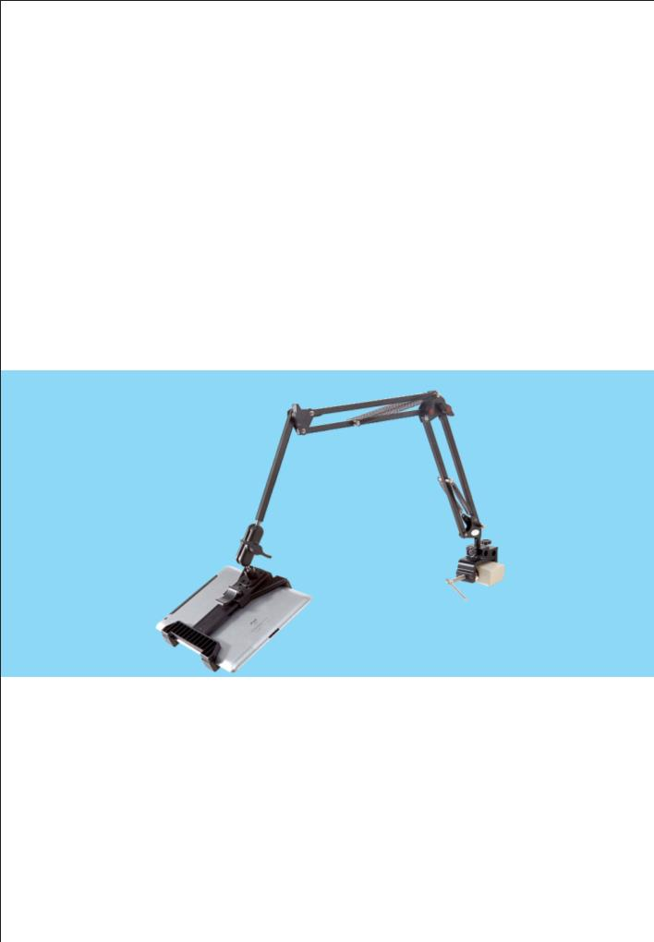
Thank you for choosing our series of products. Our company has a professional R & D and production team dedicated to the development and production of digital and lifestyle high-end products, which has received strong support and rewards from the Zhuhai Government and loved and praise by the customers.
This series of produce has obtained many national utility model patents： CN201220090384 ; CN201320218976 ;
CN201320282049 ;CN201320466057 ;CN2013206468266;
CN201320218977 ; Has been protected by national patent technology, any counterfeiting of them are infringing acts and bear legal liability.
In order to use this product correctly and better, please read this manual carefully before use.
I. Note: Special tips
1. The main raw material of the tablet and mobile phone holder is imported ABS plastic. This material has the durability of metal and the elasticity and toughness of plastic, which can clamp and not hurt digital products. But still need to pay attention to when using:
The flip-flop on the back of the flat clip cannot be pushed back strongly; when adjusting the angle of the flat clip or mobile phone, pay attention to the back. Do not overtighten the head, otherwise it will easily cause damage.
2. The paint on the head of the holder is only used as the basis for judging whether the holder has been used. Once it is used, the patent leather on this surface will be worn off. The head of the holder itself is additionally protected by a plating layer, which does not affect the service life and function.
3. When bending the main body of the holder, pay attention to the position of your fingers. Do not put it between the two poles, otherwise you may pinch your fingers.

4.When adjusting or fixing the adjustment knobs and screw clamps on the holder, pay attention to grasping the strength. It is better to screw them just to fix the holder. Excessively turning the knobs and screws may damage the knobs, clamps, or bedside tables, desktops and other object which has been clamped.

